What you expected to happen: Running index.php in Eclipse 2020-03 or 2019-nn. To stop on any indicated stop point.

What happened instead: Never stopped.

System specs: Windows 8.1 Pro; Xampp 7.4.3, Control Panel 3.2.4; c”\xampp folder; Activating Apache and MySQL only;

PHP 7.4.3 (cli) (built: Feb 18 2020 17:29:46) ( ZTS Visual C++ 2017 x64 )

Your “https://xdebug.org/wizard” indicated to use php_xdebug-2.9.3-7.4-vc15-x86_64.dll and it was properly so indicated in my php.ini:

[XDebug]
zend_extension = "C:\xampp\php\ext\php_xdebug-2.9.3-7.4-vc15-x86_64.dll"
xdebug.remote_enable = 1
xdebug.remote_handler = dbgp
xdebug.remote_host = 127.0.0.1
xdebug.remote_port = 9000
xdebug.remote_mode = req
xdebug.idkey = "ECLIPSE_DBGP_xxx"

Unless I rename the referenced zend_extension DLL in the php\ext folder so it does not match, it forces the Apache server to crash. (php_xdebug-2.9.3-7.4-vc15-x86_64.dllXXXX)

Set break point at line 4 of index.php; Debug As “PHP Web Application”;
and get this popup box:
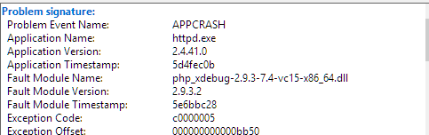

**** Could NOT run these commands – Windoze didn’t recognize “export” commands
export USE_ZEND_ALLOC=0
export ZEND_DONT_UNLOAD_MODULES=1
php index.php

